AI ASSISTED CODING LAB 14.1
__________________________________________________________________________________

NAME:VEMULA RAJEEVKALYAN
HALL TICKET NO:2403A51324
BATCH:13

Lab 14: Web Design Application – AI-Assisted HTML/CSS/JS
Generation
Lab Objectives
• Design functional, visually appealing web applications using
HTML, CSS, and JavaScript with AI assistance.
• Apply responsive, accessible, and interactive design
Week7 -
Monday
principles.
• Create practical UI components for real-world web applications.
• Use AI to optimize layout, UX, and performance.

Task 1 – Portfolio Website Design
You are building a personal portfolio website to showcase your work.
Requirements:
• Create sections for About Me, Projects, and Contact.
• Use AI to:
o Suggest color palettes and typography.
o Create a responsive layout with Grid/Flexbox.
o Add smooth scrolling navigation.

PROMPT : Build a personal portfolio website to showcase work\

CODE :

<!DOCTYPE html>
<html lang="en">
<head>
<meta charset="UTF-8" />
<meta name="viewport" content="width=device-width, initial-scale=1.0" />
<title>My Portfolio</title>

<!-- Google Fonts -->
<link href="https://fonts.googleapis.com/css2?family=Poppins:wght@600&family=Open+Sans&display=swap" rel="stylesheet">

<style>
/* ====== GLOBAL STYLES ====== */
:root {
--primary: #2d89ef;
--accent: #ffb900;
--bg: #f9fafb;
--text: #111827;
}

* {
margin: 0;
padding: 0;
box-sizing: border-box;
}

body {
font-family: 'Open Sans', sans-serif;
background: var(--bg);
color: var(--text);
scroll-behavior: smooth;
}

header {
background: var(--primary);
color: white;
padding: 1rem 2rem;
position: sticky;
top: 0;
z-index: 1000;
}

nav {
display: flex;
justify-content: space-between;
align-items: center;
}

nav h1 {
font-family: 'Poppins', sans-serif;
font-size: 1.5rem;
}

nav ul {
display: flex;
list-style: none;
gap: 1.5rem;
}

nav a {
text-decoration: none;
color: white;
font-weight: 600;
transition: color 0.3s;
}

nav a:hover {
color: var(--accent);
}

section {
padding: 4rem 2rem;
max-width: 1000px;
margin: auto;
}

h2 {
font-family: 'Poppins', sans-serif;
font-size: 2rem;
color: var(--primary);
text-align: center;
margin-bottom: 1rem;
}

p {
text-align: center;
line-height: 1.6;
}

/* ====== ABOUT ====== */
.about {
display: flex;
flex-direction: column;
align-items: center;
gap: 1.5rem;
}

.about img {
width: 150px;
height: 150px;
border-radius: 50%;
object-fit: cover;
border: 4px solid var(--primary);
}

/* ====== PROJECTS ====== */
.projects-grid {
display: grid;
grid-template-columns: repeat(auto-fit, minmax(250px, 1fr));
gap: 1.5rem;
margin-top: 2rem;
}

.project-card {
background: white;
border-radius: 10px;
box-shadow: 0 4px 8px rgba(0,0,0,0.1);
transition: transform 0.3s;
overflow: hidden;
}

.project-card:hover {
transform: translateY(-8px);
}

.project-card img {
width: 100%;
height: 180px;
object-fit: cover;
}

.project-card h3 {
font-family: 'Poppins', sans-serif;
margin: 0.8rem;
}

.project-card p {
margin: 0 0.8rem 1rem 0.8rem;
font-size: 0.9rem;
}

/* ====== CONTACT ====== */
form {
display: flex;
flex-direction: column;
gap: 1rem;
max-width: 500px;
margin: 2rem auto;
}

input, textarea {
padding: 0.8rem;
border: 1px solid #ccc;
border-radius: 6px;
font-family: inherit;
}

button {
background: var(--primary);
color: white;
padding: 0.8rem;
border: none;
border-radius: 6px;
font-weight: bold;
cursor: pointer;
transition: background 0.3s;
}

button:hover {
background: var(--accent);
color: var(--text);
}

footer {
background: var(--primary);
color: white;
text-align: center;
padding: 1rem;
margin-top: 3rem;
}

/* ====== RESPONSIVE ====== */
@media (max-width: 600px) {
nav ul {
flex-direction: column;
gap: 0.5rem;
}
}
</style>
</head>
<body>

<!-- ====== HEADER ====== -->
<header>
<nav>
<h1>My Portfolio</h1>
<ul>
<li><a href="#about">About</a></li>
<li><a href="#projects">Projects</a></li>
<li><a href="#contact">Contact</a></li>
</ul>
</nav>
</header>

<!-- ====== ABOUT SECTION ====== -->
<section id="about" class="about">
<h2>About Me</h2>
<img src="https://sraap.in/students_uploads/2403A510C7_P.jpg" alt="Pradeep Guptha">
<p>Hello! I'm <strong>Pradeep Guptha</strong>, a passionate web developer who loves creating modern, responsive, and user-friendly websites using HTML, CSS, and JavaScript. I focus on performance, accessibility, and clean design.</p>
</section>

<!-- ====== PROJECTS SECTION ====== -->
<section id="projects">
<h2>Projects</h2>
<div class="projects-grid">
<div class="project-card">
<img src="https://images.unsplash.com/photo-1522202176988-66273c2fd55f?w=600" alt="Project 1">
<h3>Portfolio Website</h3>
<p>A personal website to showcase skills and projects, designed with HTML, CSS, and JS.</p>
</div>
<div class="project-card">
<img src="https://images.unsplash.com/photo-1498050108023-c5249f4df085?w=600" alt="Project 2">
<h3>E-Commerce Store</h3>
<p>An online shop demo featuring product listings, search, and cart functionality.</p>
</div>
<div class="project-card">
<img src="https://images.unsplash.com/photo-1581092795360-fd1b0f27b23a?w=600" alt="Project 3">
<h3>Weather App</h3>
<p>A weather app that shows real-time data using OpenWeatherMap API and dynamic styling.</p>
</div>
</div>
</section>

<!-- ====== CONTACT SECTION ====== -->
<section id="contact">
<h2>Contact Me</h2>
<form onsubmit="sendMessage(event)">
<input type="text" id="name" placeholder="Your Name" required>
<input type="email" id="email" placeholder="Your Email" required>
<textarea id="message" placeholder="Your Message" rows="5" required></textarea>
<button type="submit">Send Message</button>
</form>
</section>

<footer>
<p>© 2025 Pradeep Guptha | Designed with ❤️ using HTML, CSS & JavaScript</p>
</footer>

<!-- ====== JAVASCRIPT ====== -->
<script>
// Smooth scroll enhancement for browsers without native support
document.querySelectorAll('a[href^="#"]').forEach(anchor => {
anchor.addEventListener('click', function(e) {
e.preventDefault();
document.querySelector(this.getAttribute('href')).scrollIntoView({
behavior: 'smooth'
});
});
});

// Simple form handler
function sendMessage(event) {
event.preventDefault();
const name = document.getElementById('name').value;
alert(`Thank you, ${name}! Your message has been sent successfully.`);
event.target.reset();
}
</script>

</body>
</html>

OUTPUT :

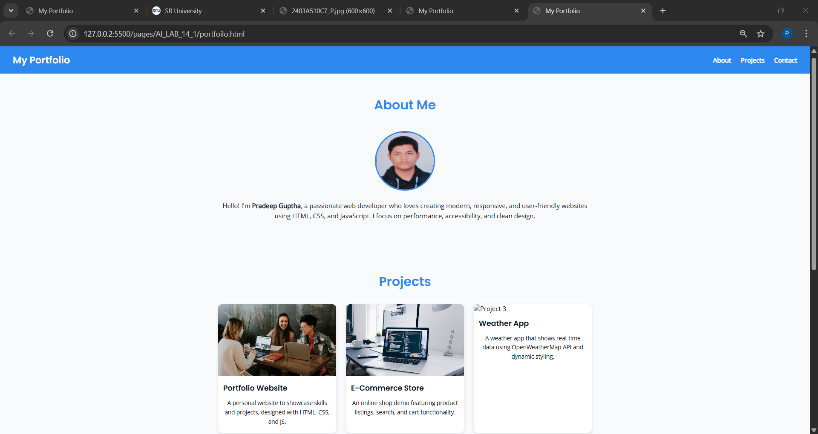

Task 2 – Online Store Product Page
Design a product display page for an online store.
Requirements:
• Display product image, title, price, and "Add to Cart" button.
• Use AI to:
o Style with BEM methodology.
o Make layout responsive.
o Add hover effects and "Add to Cart" alert.
PROMPT :

Design a product display page for an online store.

CODE : <!DOCTYPE html>
<html lang="en">
<head>
<meta charset="utf-8" />
<meta name="viewport" content="width=device-width,initial-scale=1" />
<title>ShopLite — Amazon-inspired Dark Store (32 products)</title>

<link href="https://cdn.jsdelivr.net/npm/bootstrap@5.3.3/dist/css/bootstrap.min.css" rel="stylesheet">
<link href="https://cdn.jsdelivr.net/npm/bootstrap-icons@1.11.3/font/bootstrap-icons.css" rel="stylesheet">

<style>
:root{
--bg:#0f1720; --card:#0b1220; --muted:#98a0ac; --accent:#ffb300;
}
html,body{background:var(--bg);color:#e6eef8;height:100%;}
a{color:var(--accent);}
.navbar, .footer{background:#071022}
.hero .carousel-item img{height:420px;object-fit:cover}
.product-card{background:linear-gradient(180deg, rgba(255,255,255,0.02), rgba(255,255,255,0.01));border:1px solid rgba(255,255,255,0.03);}
.product-card img{height:180px;object-fit:cover}
.price{color:#dff0c6;font-weight:700}
.old-price{opacity:.55;text-decoration:line-through;margin-left:.5rem;color:var(--muted)}
.scrolling-wrapper{display:flex;gap:1rem;overflow-x:auto;padding-bottom:8px}
.scrolling-wrapper::-webkit-scrollbar{height:8px}
.scrolling-wrapper::-webkit-scrollbar-thumb{background:#2b2f36;border-radius:6px}
.badge-cat{background:#122233;color:#aee;padding:0.18rem .5rem;border-radius:999px}
.filter-card{background:linear-gradient(180deg, rgba(255,255,255,0.01), rgba(255,255,255,0.02));border:1px solid rgba(255,255,255,0.03)}
.btn-accent{background:var(--accent);border-color:var(--accent);color:#0b1220}
.rating{color:#ffd166}
.text-muted-2{color:#94a3b8}
@media (max-width:575px){ .hero .carousel-item img{height:220px} }
</style>
</head>
<body>

<!-- NAVBAR -->
<nav class="navbar navbar-expand-lg navbar-dark sticky-top">
<div class="container-fluid px-3">
<a class="navbar-brand d-flex align-items-center gap-2" href="#"><i class="bi bi-bag-fill fs-4 text-warning"></i><span class="fw-bold">ShopLite</span></a>
<button class="navbar-toggler" type="button" data-bs-toggle="collapse" data-bs-target="#navMain"><span class="navbar-toggler-icon"></span></button>

<div class="collapse navbar-collapse" id="navMain">
<form id="navSearchForm" class="d-flex mx-auto w-50" role="search">
<div class="input-group">
<input id="navSearchInput" class="form-control" type="search" placeholder="Search products, brands, categories" aria-label="Search">
<button class="btn btn-accent" type="submit" title="Search"><i class="bi bi-search"></i></button>
</div>
</form>

<ul class="navbar-nav ms-auto align-items-center">
<li class="nav-item me-3"><a class="nav-link" href="#">Hello, Sign in</a></li>
<li class="nav-item me-3"><a class="nav-link" href="#">Orders</a></li>
<li class="nav-item">
<button class="btn btn-outline-light position-relative" type="button" data-bs-toggle="offcanvas" data-bs-target="#cartOffcanvas" aria-controls="cartOffcanvas">
<i class="bi bi-cart3"></i>
<span id="cartCountBadge" class="position-absolute top-0 start-100 translate-middle badge rounded-pill bg-danger">0</span>
</button>
</li>
</ul>
</div>
</div>
</nav>

<!-- HERO SLIDER -->
<section class="hero mb-4">
<div id="heroCarousel" class="carousel slide" data-bs-ride="carousel">
<div class="carousel-inner">
<div class="carousel-item active">
<img src="https://images.unsplash.com/photo-1517336714731-489689fd1ca8?w=1600&h=420&fit=crop" class="d-block w-100" alt="banner1">
</div>
<div class="carousel-item">
<img src="https://images.unsplash.com/photo-1542291026-7eec264c27ff?w=1600&h=420&fit=crop" class="d-block w-100" alt="banner2">
</div>
<div class="carousel-item">
<img src="https://images.unsplash.com/photo-1512499617640-c2f999098c8e?w=1600&h=420&fit=crop" class="d-block w-100" alt="banner3">
</div>
</div>
<button class="carousel-control-prev" type="button" data-bs-target="#heroCarousel" data-bs-slide="prev"><span class="carousel-control-prev-icon"></span></button>
<button class="carousel-control-next" type="button" data-bs-target="#heroCarousel" data-bs-slide="next"><span class="carousel-control-next-icon"></span></button>
</div>
</section>

<!-- MAIN: Sidebar + Grid -->
<main class="container mb-5">
<div class="row g-4">
<!-- FILTER SIDEBAR -->
<aside class="col-12 col-lg-3 order-2 order-lg-1">
<div class="p-3 filter-card rounded-3">
<h5 class="mb-3">Filters</h5>

<div class="mb-3">
<label class="form-label small text-muted-2 mb-2">Category</label>
<div id="categoryChips" class="d-flex flex-wrap gap-2"></div>
</div>

<div class="mb-3">
<label for="priceRange" class="form-label small text-muted-2">Max price: <strong id="priceValue">₹50,000</strong></label>
<input type="range" class="form-range" id="priceRange" min="100" max="100000" step="100" value="50000">
</div>

<div class="mb-3">
<label class="form-label small text-muted-2">Minimum rating</label>
<select id="minRating" class="form-select">
<option value="0">Any</option>
<option value="3">3★ & up</option>
<option value="4">4★ & up</option>
<option value="4.5">4.5★ & up</option>
</select>
</div>

<div class="mb-3">
<label class="form-label small text-muted-2">Sort</label>
<select id="sortBy" class="form-select">
<option value="featured">Featured</option>
<option value="price-asc">Price: Low to High</option>
<option value="price-desc">Price: High to Low</option>
<option value="rating-desc">Rating</option>
<option value="newest">Newest</option>
</select>
</div>

<div class="d-grid gap-2">
<button id="applyFilters" class="btn btn-accent">Apply</button>
<button id="resetFilters" class="btn btn-outline-light">Reset</button>
</div>
</div>
</aside>

<!-- PRODUCTS GRID -->
<section class="col-12 col-lg-9 order-1 order-lg-2">
<div class="d-flex justify-content-between align-items-center mb-3">
<h4 class="mb-0">All Products</h4>
<small class="text-muted-2">Showing <span id="showingCount">0</span> of <span id="totalCount">0</span></small>
</div>

<div id="productGrid" class="row row-cols-1 row-cols-md-2 row-cols-lg-3 row-cols-xl-4 g-4"></div>

<nav class="mt-4"><ul id="pagination" class="pagination justify-content-center"></ul></nav>
</section>
</div>
</main>

<!-- HORIZONTAL CAROUSELS -->
<section class="container mb-5">
<h6 class="text-muted-2">Customers also bought</h6>
<div id="carouselRow1" class="scrolling-wrapper py-3 mb-4"></div>

<h6 class="text-muted-2">Top rated in Electronics</h6>
<div id="carouselRow2" class="scrolling-wrapper py-3 mb-4"></div>

<h6 class="text-muted-2">Home & Kitchen picks</h6>
<div id="carouselRow3" class="scrolling-wrapper py-3 mb-4"></div>
</section>

<!-- NEWSLETTER -->
<section class="container text-center mb-5">
<div class="p-4 filter-card rounded-3">
<h5>Get deals in your inbox</h5>
<form id="newsletterForm" class="row g-2 justify-content-center mt-2">
<div class="col-md-4"><input id="newsEmail" type="email" class="form-control" placeholder="Email address" required></div>
<div class="col-md-auto"><button class="btn btn-accent">Subscribe</button></div>
</form>
</div>
</section>

<!-- FOOTER -->
<footer class="footer py-4 text-muted">
<div class="container text-center small">
© <span id="year"></span> ShopLite — Inspired design
</div>
</footer>

<!-- CART OFFCANVAS -->
<div class="offcanvas offcanvas-end text-white" tabindex="-1" id="cartOffcanvas">
<div class="offcanvas-header">
<h5 class="offcanvas-title">Your Cart</h5>
<button type="button" class="btn-close btn-close-white" data-bs-dismiss="offcanvas"></button>
</div>
<div class="offcanvas-body d-flex flex-column bg-dark">
<div id="cartItems" class="mb-3"></div>
<div class="mt-auto">
<div class="d-flex justify-content-between align-items-center mb-3"><strong>Total</strong><strong id="cartTotal">₹0</strong></div>
<div class="d-grid gap-2">
<button id="checkoutBtn" class="btn btn-accent">Proceed to Checkout</button>
<button class="btn btn-outline-light" data-bs-dismiss="offcanvas">Continue Shopping</button>
</div>
</div>
</div>
</div>

<!-- QUICK VIEW MODAL -->
<div class="modal fade" id="quickViewModal" tabindex="-1">
<div class="modal-dialog modal-lg modal-dialog-centered">
<div class="modal-content bg-dark text-white">
<div class="modal-header border-0">
<h5 class="modal-title" id="qvTitle"></h5>
<button type="button" class="btn-close btn-close-white" data-bs-dismiss="modal"></button>
</div>
<div class="modal-body">
<div class="row g-3">
<div class="col-md-6"><img id="qvImg" src="" class="img-fluid rounded" alt=""></div>
<div class="col-md-6">
<p id="qvCat" class="small text-muted-2"></p>
<div class="h4"><span id="qvPrice" class="price"></span> <small id="qvOld" class="old-price"></small></div>
<div id="qvRating" class="rating small mb-2"></div>
<p id="qvDesc" class="small text-muted-2"></p>
<div class="d-flex gap-2 mt-3">
<button id="qvAdd" class="btn btn-accent"><i class="bi bi-cart-plus"></i> Add to cart</button>
<button class="btn btn-outline-light" data-bs-dismiss="modal">Close</button>
</div>
</div>
</div>
</div>
</div>
</div>
</div>

<!-- BOOTSTRAP JS -->
<script src="https://cdn.jsdelivr.net/npm/bootstrap@5.3.3/dist/js/bootstrap.bundle.min.js"></script>

<script>
/* ---------- Data: 32 Products (images use fixed size params to avoid broken images) ---------- */
const PRODUCTS = [
{id:1,name:'AeroPhone X12',category:'Electronics',price:14999,oldPrice:17999,rating:4.3,img:'https://images.unsplash.com/photo-1580894894512-2b9bdf0f9f87?w=800&h=600&fit=crop',desc:'Compact smartphone with great camera',featured:true,createdAt:1},
{id:2,name:'Nimbus Laptop 14',category:'Electronics',price:55999,oldPrice:68999,rating:4.5,img:'https://images.unsplash.com/photo-1526170375885-4d8ecf77b99f?w=800&h=600&fit=crop',desc:'Lightweight laptop for work & play',featured:true,createdAt:2},
{id:3,name:'Pulse Earbuds',category:'Electronics',price:2499,oldPrice:3499,rating:4.1,img:'https://images.unsplash.com/photo-1505740420928-5e560c06d30e?w=800&h=600&fit=crop',desc:'Noise-cancelling earbuds',featured:false,createdAt:3},
{id:4,name:'TabPro 10',category:'Electronics',price:19999,oldPrice:22999,rating:4.0,img:'https://images.unsplash.com/photo-1593642634367-d91a135587b5?w=800&h=600&fit=crop',desc:'Tablet for entertainment & notes',featured:false,createdAt:4},
{id:5,name:'Stride Running Shoes',category:'Fashion',price:2499,oldPrice:3499,rating:4.2,img:'https://images.unsplash.com/photo-1491553895911-0055eca6402d?w=800&h=600&fit=crop',desc:'Breathable running shoes',featured:true,createdAt:5},
{id:6,name:'Metro Jacket',category:'Fashion',price:3499,oldPrice:4999,rating:4.4,img:'https://images.unsplash.com/photo-1521572163474-6864f9cf17ab?w=800&h=600&fit=crop',desc:'Warm stylish jacket',featured:false,createdAt:6},
{id:7,name:'Classic Wristwatch',category:'Fashion',price:4499,oldPrice:5999,rating:4.6,img:'https://images.unsplash.com/photo-1517336714731-489689fd1ca8?w=800&h=600&fit=crop',desc:'Analog watch with leather strap',featured:true,createdAt:7},
{id:8,name:'KitchenPro Blender',category:'Home',price:1799,oldPrice:2499,rating:4.0,img:'https://images.unsplash.com/photo-1588167056543-6a3c1c56f8f4?w=800&h=600&fit=crop',desc:'Smoothie blender with multi-speed',featured:false,createdAt:8},
{id:9,name:'Comfort Pillow',category:'Home',price:999,oldPrice:1299,rating:3.9,img:'https://images.unsplash.com/photo-1505691723518-36a7d1a3c71a?w=800&h=600&fit=crop',desc:'Memory foam pillow',featured:false,createdAt:9},
{id:10,name:'Spark LED Lamp',category:'Home',price:699,oldPrice:999,rating:4.1,img:'https://images.unsplash.com/photo-1505692794400-8fe5b5f4e3a3?w=800&h=600&fit=crop',desc:'Adjustable bedside lamp',featured:false,createdAt:10},
{id:11,name:'ProCook Pan',category:'Home',price:1299,oldPrice:1699,rating:4.3,img:'https://images.unsplash.com/photo-1518976024611-28bf4a67a6f6?w=800&h=600&fit=crop',desc:'Non-stick frying pan',featured:false,createdAt:11},
{id:12,name:'Yoga Mat Deluxe',category:'Sports',price:799,oldPrice:1199,rating:4.2,img:'https://images.unsplash.com/photo-1599058917219-9f2e1e4bde3f?w=800&h=600&fit=crop',desc:'High grip yoga mat',featured:false,createdAt:12},
{id:13,name:'Cricket Bat Pro',category:'Sports',price:5499,oldPrice:6999,rating:4.5,img:'https://images.unsplash.com/photo-1521412644187-c49fa049e84d?w=800&h=600&fit=crop',desc:'Willow bat for all levels',featured:true,createdAt:13},
{id:14,name:'The Wanderer (Novel)',category:'Books',price:399,oldPrice:499,rating:4.7,img:'https://images.unsplash.com/photo-1512820790803-83ca734da794?w=800&h=600&fit=crop',desc:'Bestselling adventure novel',featured:false,createdAt:14},
{id:15,name:'Notebook Set',category:'Books',price:299,oldPrice:399,rating:4.0,img:'https://images.unsplash.com/photo-1516979187457-637abb4f9353?w=800&h=600&fit=crop',desc:'Journal with ruled pages',featured:false,createdAt:15},
{id:16,name:'Grooming Kit',category:'Beauty',price:1599,oldPrice:2199,rating:4.1,img:'https://images.unsplash.com/photo-1543163521-1bf539c55f3b?w=800&h=600&fit=crop',desc:'All-in-one grooming kit',featured:false,createdAt:16},
{id:17,name:'Face Serum',category:'Beauty',price:899,oldPrice:1299,rating:4.4,img:'https://images.unsplash.com/photo-1585238341979-2fe6c9f8e6f9?w=800&h=600&fit=crop',desc:'Hydrating face serum',featured:true,createdAt:17},
{id:18,name:'Cordless Drill',category:'Tools',price:3499,oldPrice:4499,rating:4.2,img:'https://images.unsplash.com/photo-1519744792095-2f2205e87b6f?w=800&h=600&fit=crop',desc:'Powerful drill with battery',featured:false,createdAt:18},
{id:19,name:'Smart Bulb (4-pack)',category:'Home',price:1999,oldPrice:2499,rating:4.3,img:'https://images.unsplash.com/photo-1505691723518-36a7d1a3c71a?w=800&h=600&fit=crop',desc:'Color changing smart bulbs',featured:false,createdAt:19},
{id:20,name:'Desk Chair Ergonomic',category:'Home',price:8999,oldPrice:11999,rating:4.0,img:'https://images.unsplash.com/photo-1540574163026-643ea20ade25?w=800&h=600&fit=crop',desc:'Comfort chair for long work',featured:false,createdAt:20},
{id:21,name:'Action Camera',category:'Electronics',price:7999,oldPrice:9999,rating:4.1,img:'https://images.unsplash.com/photo-1519181245277-cffeb31da2a2?w=800&h=600&fit=crop',desc:'Waterproof action camera',featured:false,createdAt:21},
{id:22,name:'Wireless Charger',category:'Electronics',price:1299,oldPrice:1699,rating:4.0,img:'https://images.unsplash.com/photo-1545239705-6c6be3a8a7d6?w=800&h=600&fit=crop',desc:'Fast charging pad',featured:false,createdAt:22},
{id:23,name:'Sunglasses UV',category:'Fashion',price:799,oldPrice:1299,rating:3.8,img:'https://images.unsplash.com/photo-1503341455253-b2e723bb3dbb?w=800&h=600&fit=crop',desc:'Polarized sunglasses',featured:false,createdAt:23},
{id:24,name:'Kids Toy Set',category:'Toys',price:599,oldPrice:799,rating:4.2,img:'https://images.unsplash.com/photo-1512621776951-a57141f2eefd?w=800&h=600&fit=crop',desc:'Educational toy set',featured:false,createdAt:24},
{id:25,name:'BBQ Grill',category:'Home',price:12999,oldPrice:15999,rating:4.4,img:'https://images.unsplash.com/photo-1506368249639-73a05d6f6488?w=800&h=600&fit=crop',desc:'Outdoor BBQ grill',featured:true,createdAt:25},
{id:26,name:'Gaming Mouse',category:'Electronics',price:1499,oldPrice:1999,rating:4.3,img:'https://images.unsplash.com/photo-1517336714731-489689fd1ca8?w=800&h=600&fit=crop',desc:'Ergonomic gaming mouse',featured:false,createdAt:26},
{id:27,name:'Wireless Keyboard',category:'Electronics',price:2199,oldPrice:2799,rating:4.0,img:'https://images.unsplash.com/photo-1512499617640-c2f999098c8e?w=800&h=600&fit=crop',desc:'Slim bluetooth keyboard',featured:false,createdAt:27},
{id:28,name:'Electric Kettle',category:'Home',price:1299,oldPrice:1599,rating:4.1,img:'https://images.unsplash.com/photo-1541542684-415b7d6a4f72?w=800&h=600&fit=crop',desc:'Quick boil kettle',featured:false,createdAt:28},
{id:29,name:'Protein Powder',category:'Health',price:2499,oldPrice:3299,rating:4.2,img:'https://images.unsplash.com/photo-1598970434795-0c54fe7c0642?w=800&h=600&fit=crop',desc:'Whey protein supplement',featured:false,createdAt:29},
{id:30,name:'Portable Speaker',category:'Electronics',price:3499,oldPrice:4499,rating:4.3,img:'https://images.unsplash.com/photo-1518449032-1b8e3d4c6d70?w=800&h=600&fit=crop',desc:'Bluetooth portable speaker',featured:false,createdAt:30},
{id:31,name:'Leather Wallet',category:'Fashion',price:1199,oldPrice:1599,rating:4.1,img:'https://images.unsplash.com/photo-1520975916764-2c1a8a2f2c2b?w=800&h=600&fit=crop',desc:'Genuine leather wallet',featured:false,createdAt:31},
{id:32,name:'Running Socks (3pk)',category:'Fashion',price:499,oldPrice:699,rating:4.0,img:'https://images.unsplash.com/photo-1520975916764-2c1a8a2f2c2b?w=800&h=600&fit=crop',desc:'Comfort sports socks',featured:false,createdAt:32}
];

/* ---------- State ---------- */
let state = { query:'', categories: new Set(PRODUCTS.map(p=>p.category)), maxPrice:50000, minRating:0, sortBy:'featured', page:1, pageSize:12 };
let CART = {}; // id => qty

/* ---------- Helpers ---------- */
const $ = (s,r=document)=>r.querySelector(s);
const $$ = (s,r=document)=>Array.from(r.querySelectorAll(s));
const currency = n => `₹${n.toLocaleString('en-IN')}`;
function starRating(r){ const full=Math.floor(r), half=(r-full)>=0.5?1:0, empty=5-full-half; return '★'.repeat(full)+(half?'½':'')+'☆'.repeat(empty); }

/* ---------- Render Category Chips ---------- */
function renderCategoryChips(){
const container = $('#categoryChips'); container.innerHTML='';
const cats = Array.from(new Set(PRODUCTS.map(p=>p.category))).sort();
cats.forEach(c=>{
const btn = document.createElement('button');
btn.type='button';
btn.className='btn btn-sm btn-outline-light';
btn.textContent = c;
btn.dataset.cat = c;
btn.addEventListener('click', ()=>{ if(state.categories.has(c)) state.categories.delete(c); else state.categories.add(c); renderFilters(); render(); });
container.appendChild(btn);
});
}
function renderFilters(){
$$('#categoryChips button').forEach(btn=>{ btn.classList.toggle('btn-accent', state.categories.has(btn.dataset.cat)); });
$('#priceRange').value = state.maxPrice;
$('#priceValue').textContent = currency(state.maxPrice);
$('#minRating').value = state.minRating;
$('#sortBy').value = state.sortBy;
}

/* ---------- Filter, Sort, Paginate ---------- */
function getFiltered(){
let items = PRODUCTS.filter(p=> state.categories.has(p.category));
items = items.filter(p=> p.price <= state.maxPrice && p.rating >= state.minRating);
if(state.query) {
const q = state.query.toLowerCase();
items = items.filter(p=> p.name.toLowerCase().includes(q) || p.desc.toLowerCase().includes(q) || p.category.toLowerCase().includes(q));
}
switch(state.sortBy){
case 'price-asc': items.sort((a,b)=>a.price-b.price); break;
case 'price-desc': items.sort((a,b)=>b.price-a.price); break;
case 'rating-desc': items.sort((a,b)=>b.rating-a.rating); break;
case 'newest': items.sort((a,b)=>b.createdAt-a.createdAt); break;
default: items.sort((a,b)=> (b.featured - a.featured) || (b.rating - a.rating));
}
return items;
}
function paginate(items){
const total = items.length; const pages = Math.max(1, Math.ceil(total/state.pageSize));
if(state.page>pages) state.page=1;
const start = (state.page-1) * state.pageSize;
return { slice: items.slice(start, start+state.pageSize), total, pages };
}
function renderPagination(totalPages){
const ul = $('#pagination'); ul.innerHTML = '';
const mk = (label,page,disabled=false,active=false)=>`<li class="page-item ${disabled?'disabled':''} ${active?'active':''}"><a class="page-link" href="#" data-page="${page}">${label}</a></li>`;
ul.insertAdjacentHTML('beforeend', mk('&laquo;', Math.max(1,state.page-1), state.page===1));
for(let p=1;p<=totalPages;p++) ul.insertAdjacentHTML('beforeend', mk(p,p,false,state.page===p));
ul.insertAdjacentHTML('beforeend', mk('&raquo;', Math.min(totalPages,state.page+1), state.page===totalPages));
}

/* ---------- Product Grid ---------- */
function cardHTML(p){
return `
<div class="col">
<div class="card product-card h-100 shadow-sm">
<img src="${p.img}" class="card-img-top" alt="${p.name}">
<div class="card-body d-flex flex-column">
<div class="d-flex justify-content-between align-items-start mb-1">
<small class="badge-cat small">${p.category}</small>
<small class="text-muted small">${p.rating.toFixed(1)} ★</small>
</div>
<h6 class="card-title mb-1">${p.name}</h6>
<p class="text-muted-2 small mb-2">${p.desc}</p>
<div class="mt-auto d-flex justify-content-between align-items-center">
<div>
<div class="price">${currency(p.price)}</div>
<div class="old-price small">${currency(p.oldPrice)}</div>
</div>
<div class="d-flex flex-column align-items-end">
<div class="btn-group-vertical">
<button class="btn btn-sm btn-outline-light" data-action="quick" data-id="${p.id}" title="Quick view"><i class="bi bi-eye"></i></button>
<button class="btn btn-sm btn-accent" data-action="add" data-id="${p.id}" title="Add to cart"><i class="bi bi-cart-plus"></i></button>
</div>
</div>
</div>
</div>
</div>
</div>`;
}

function render(){
const filtered = getFiltered();
$('#totalCount').textContent = PRODUCTS.length;
$('#showingCount').textContent = filtered.length;
const { slice, total, pages } = paginate(filtered);
$('#productGrid').innerHTML = slice.map(cardHTML).join('');
renderPagination(pages);
attachCardListeners();
}

/* ---------- Carousels Rows ---------- */
function renderCarousels(){
const row1 = $('#carouselRow1'), row2 = $('#carouselRow2'), row3 = $('#carouselRow3');
row1.innerHTML=''; row2.innerHTML=''; row3.innerHTML='';
const top = PRODUCTS.filter(p=>p.featured).slice(0,12);
const electronics = PRODUCTS.filter(p=>p.category==='Electronics').slice(0,12);
const home = PRODUCTS.filter(p=>p.category==='Home').slice(0,12);
[[row1,top],[row2,electronics],[row3,home]].forEach(([el,arr])=>{
arr.forEach(p=>{
const card = document.createElement('div');
card.className='card p-2';
card.style.minWidth='200px';
card.innerHTML = `<img src="${p.img}" class="card-img-top rounded" alt="${p.name}"><div class="card-body small text-white-50 p-2"><div>${p.name}</div><div class="price small">${currency(p.price)}</div></div>`;
el.appendChild(card);
});
});
}

/* ---------- Auto-scroll Carousels ---------- */
function startAutoScroll(){
['carouselRow1','carouselRow2','carouselRow3'].forEach(id=>{
const el = document.getElementById(id); if(!el) return;
let pos = 0, speed = 0.6, raf;
function step(){ pos += speed; if(pos > el.scrollWidth - el.clientWidth) pos = 0; el.scrollLeft = pos; raf = requestAnimationFrame(step); }
raf = requestAnimationFrame(step);
el.addEventListener('mouseenter', ()=> cancelAnimationFrame(raf));
el.addEventListener('mouseleave', ()=> { raf = requestAnimationFrame(step); });
});
}

/* ---------- Card Buttons ---------- */
function attachCardListeners(){
$$('[data-action="quick"]').forEach(b=> b.addEventListener('click', (e)=>{ const id=+e.currentTarget.dataset.id; openQuickView(id); }));
$$('[data-action="add"]').forEach(b=> b.addEventListener('click', (e)=>{ const id=+e.currentTarget.dataset.id; addToCart(id,1); }));
}

/* ---------- Quick View ---------- */
function openQuickView(id){
const p = PRODUCTS.find(x=>x.id===id); if(!p) return;
$('#qvTitle').textContent = p.name;
$('#qvImg').src = p.img;
$('#qvCat').textContent = p.category;
$('#qvPrice').textContent = currency(p.price);
$('#qvOld').textContent = currency(p.oldPrice);
$('#qvRating').textContent = `${p.rating} / 5 ${starRating(p.rating)}`;
$('#qvDesc').textContent = p.desc;
$('#qvAdd').onclick = ()=>{ addToCart(id,1); bootstrap.Modal.getOrCreateInstance('#quickViewModal').hide(); bootstrap.Offcanvas.getOrCreateInstance('#cartOffcanvas').show(); };
new bootstrap.Modal('#quickViewModal').show();
}

/* ---------- Cart ---------- */
function addToCart(id,qty=1){
CART[id] = (CART[id]||0) + qty;
renderCart();
}
function removeFromCart(id){
delete CART[id];
renderCart();
}
function changeQty(id,qty){
if(qty<=0) removeFromCart(id); else CART[id]=qty;
renderCart();
}
function renderCart(){
const container = $('#cartItems'); container.innerHTML='';
let total = 0;
const ids = Object.keys(CART).map(x=>+x);
if(ids.length===0){ container.innerHTML = `<div class="text-center text-muted-2">Your cart is empty.</div>`; $('#cartCountBadge').textContent = 0; $('#cartTotal').textContent = currency(0); return; }
ids.forEach(id=>{
const p = PRODUCTS.find(x=>x.id===id); const qty = CART[id]; const line = p.price * qty; total += line;
const div = document.createElement('div'); div.className='d-flex gap-2 align-items-center mb-3';
div.innerHTML = `<img src="${p.img}" style="width:64px;height:64px;object-fit:cover" class="rounded">
<div class="flex-grow-1 small">
<div class="fw-bold">${p.name}</div>
<div class="text-muted-2 small">${currency(p.price)} x ${qty} = ${currency(line)}</div>
<div class="mt-2 d-flex gap-2">
<input type="number" min="0" value="${qty}" class="form-control form-control-sm" style="width:80px" data-cart-qty data-id="${id}">
<button class="btn btn-sm btn-outline-light" data-cart-remove data-id="${id}"><i class="bi bi-trash"></i></button>
</div>
</div>`;
container.appendChild(div);
});
$('#cartCountBadge').textContent = ids.length;
$('#cartTotal').textContent = currency(total);
$$('[data-cart-qty]').forEach(inp=> inp.addEventListener('change', (e)=>{ const id=+e.target.dataset.id; const q=+e.target.value; changeQty(id,q); }));
$$('[data-cart-remove]').forEach(b=> b.addEventListener('click', (e)=>{ const id=+e.currentTarget.dataset.id; removeFromCart(id); }));
}

/* ---------- Search & Filters binding ---------- */
$('#navSearchForm').addEventListener('submit', (e)=>{ e.preventDefault(); state.query = $('#navSearchInput').value.trim(); state.page = 1; render(); });
$('#applyFilters').addEventListener('click', ()=>{ state.page = 1; render(); });
$('#resetFilters').addEventListener('click', ()=>{ state = {...state, categories:new Set(PRODUCTS.map(p=>p.category)), maxPrice:50000, minRating:0, sortBy:'featured', page:1}; renderFilters(); render(); });
$('#priceRange').addEventListener('input',(e)=>{ state.maxPrice = +e.target.value; $('#priceValue').textContent = currency(state.maxPrice); });
$('#minRating').addEventListener('change',(e)=>{ state.minRating = parseFloat(e.target.value); });
$('#sortBy').addEventListener('change',(e)=>{ state.sortBy = e.target.value; });

$('#pagination').addEventListener('click',(e)=>{ const a = e.target.closest('a[data-page]'); if(!a) return; e.preventDefault(); state.page = +a.dataset.page; render(); });

$('#newsletterForm').addEventListener('submit',(e)=>{ e.preventDefault(); if(!$('#newsEmail').checkValidity()){ e.stopPropagation(); $('#newsletterForm').classList.add('was-validated'); return; } alert('Thanks! You are subscribed.'); $('#newsletterForm').reset(); });

/* ---------- Init ---------- */
(function init(){
document.getElementById('year').textContent = new Date().getFullYear();
renderCategoryChips();
renderFilters();
render();
renderCarousels();
startAutoScroll();
renderCart();
})();
</script>
</body>
</html>

OUTPUT :

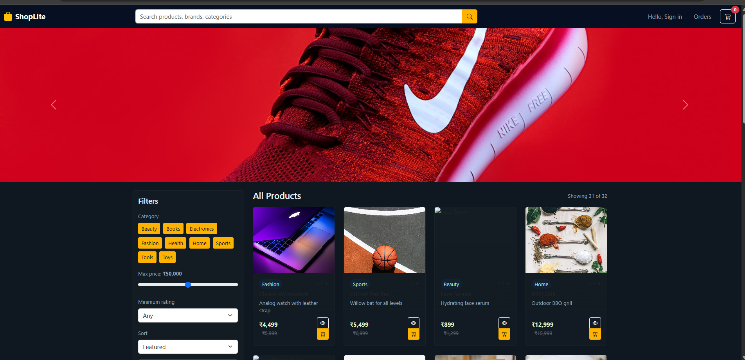

Task 3 – Event Registration Form
Build an event registration form for a conference.
Requirements:
• Collect name, email, phone number, and session selection.
• Use AI to:
o Add form validation with JavaScript.
o Make the form accessible with labels and ARIA.
o Style with a professional look.

PROMPT : Build an event registration form for a conference

CODE :

<!DOCTYPE html>
<html lang="en">
<head>
<meta charset="UTF-8" />
<meta name="viewport" content="width=device-width, initial-scale=1.0" />
<title>Conference Registration Form</title>

<!-- Google Fonts -->
<link href="https://fonts.googleapis.com/css2?family=Poppins:wght@600&family=Open+Sans&display=swap" rel="stylesheet">

<style>
:root {
--primary: #0052cc;
--accent: #ffb900;
--bg: #f7f9fc;
--text: #1a1a1a;
--error: #e63946;
}

* {
box-sizing: border-box;
margin: 0;
padding: 0;
}

body {
font-family: 'Open Sans', sans-serif;
background: var(--bg);
color: var(--text);
display: flex;
justify-content: center;
align-items: center;
min-height: 100vh;
padding: 20px;
}

.container {
background: white;
border-radius: 10px;
box-shadow: 0 5px 20px rgba(0, 0, 0, 0.1);
width: 100%;
max-width: 450px;
padding: 2rem;
text-align: center;
}

h1 {
font-family: 'Poppins', sans-serif;
color: var(--primary);
margin-bottom: 1rem;
}

p {
color: #555;
margin-bottom: 2rem;
}

form {
display: flex;
flex-direction: column;
gap: 1rem;
text-align: left;
}

label {
font-weight: 600;
margin-bottom: 0.3rem;
display: block;
}

input, select {
padding: 0.8rem;
border: 1px solid #ccc;
border-radius: 6px;
font-size: 1rem;
width: 100%;
transition: border-color 0.3s;
}

input:focus, select:focus {
border-color: var(--primary);
outline: none;
box-shadow: 0 0 5px rgba(0,82,204,0.2);
}

.error {
color: var(--error);
font-size: 0.9rem;
}

button {
background: var(--primary);
color: white;
border: none;
padding: 0.9rem;
border-radius: 6px;
font-size: 1rem;
cursor: pointer;
transition: background 0.3s;
font-family: 'Poppins', sans-serif;
}

button:hover {
background: var(--accent);
color: var(--text);
}

.success {
color: green;
text-align: center;
margin-top: 1rem;
font-weight: bold;
}
</style>
</head>
<body>

<div class="container" role="form" aria-labelledby="formTitle">
<h1 id="formTitle">Conference Registration</h1>
<p>Please fill out the form below to register for the event.</p>

<form id="registrationForm" novalidate>
<div>
<label for="name">Full Name:</label>
<input type="text" id="name" name="name" placeholder="Enter your full name" aria-required="true" required />
<span class="error" id="nameError"></span>
</div>

<div>
<label for="email">Email Address:</label>
<input type="email" id="email" name="email" placeholder="example@domain.com" aria-required="true" required />
<span class="error" id="emailError"></span>
</div>

<div>
<label for="phone">Phone Number:</label>
<input type="tel" id="phone" name="phone" placeholder="e.g. 9876543210" aria-required="true" required />
<span class="error" id="phoneError"></span>
</div>

<div>
<label for="session">Select Session:</label>
<select id="session" name="session" aria-required="true" required>
<option value="">-- Select a session --</option>
<option value="webdev">Web Development Trends 2025</option>
<option value="ai">AI in Everyday Life</option>
<option value="cybersecurity">Cybersecurity & Ethics</option>
<option value="cloud">Cloud Computing Essentials</option>
</select>
<span class="error" id="sessionError"></span>
</div>

<button type="submit">Register Now</button>
<p class="success" id="successMsg"></p>
</form>
</div>

<script>
// FORM VALIDATION SCRIPT
const form = document.getElementById('registrationForm');
const nameField = document.getElementById('name');
const emailField = document.getElementById('email');
const phoneField = document.getElementById('phone');
const sessionField = document.getElementById('session');
const successMsg = document.getElementById('successMsg');

form.addEventListener('submit', function(e) {
e.preventDefault();

// Reset errors
document.querySelectorAll('.error').forEach(el => el.textContent = '');
successMsg.textContent = '';

let valid = true;

// Name validation
if (nameField.value.trim().length < 3) {
document.getElementById('nameError').textContent = 'Please enter your full name.';
valid = false;
}

// Email validation (simple regex)
const emailPattern = /^[^ ]+@[^ ]+\.[a-z]{2,3}$/;
if (!emailPattern.test(emailField.value.trim())) {
document.getElementById('emailError').textContent = 'Please enter a valid email address.';
valid = false;
}

// Phone validation (10 digits)
const phonePattern = /^[0-9]{10}$/;
if (!phonePattern.test(phoneField.value.trim())) {
document.getElementById('phoneError').textContent = 'Enter a valid 10-digit phone number.';
valid = false;
}

// Session validation
if (sessionField.value === "") {
document.getElementById('sessionError').textContent = 'Please select a session.';
valid = false;
}

// If valid, show success
if (valid) {
successMsg.textContent = '✅ Registration successful! Thank you for joining.';
form.reset();
}
});
</script>

</body>
</html>

OUTPUT :

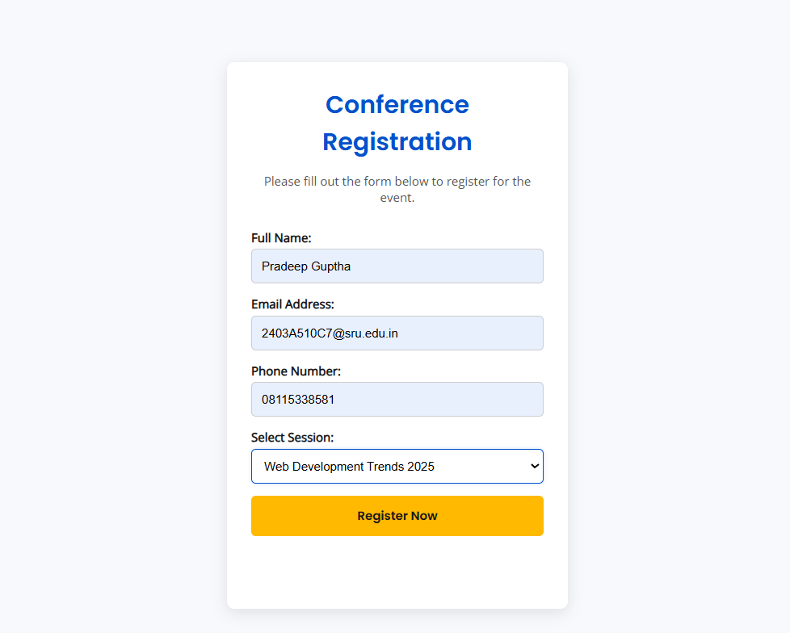

Task Description #4 (Data – Fetch API & Render List with
Loading/Error States)
• Task: Fetch JSON from an API and render items to the DOM
with loading and error UI.
• Instructions:
o Ask AI to write fetch() logic, create DOM nodes safely,
and add skeleton/loading text.

PROMPT : Fetch JSON from an API and render items to the DOM
with loading and error UI.

CODE :
<!DOCTYPE html>
<html lang="en">
<head>
<meta charset="UTF-8">
<meta name="viewport" content="width=device-width, initial-scale=1.0">
<title>Fetch API – Loading & Error Handling</title>

<style>
:root {
--primary: #2563eb;
--bg: #f9fafb;
--text: #111827;
--error: #dc2626;
--card-bg: #fff;
}

body {
font-family: "Open Sans", sans-serif;
background: var(--bg);
color: var(--text);
display: flex;
flex-direction: column;
align-items: center;
padding: 2rem;
min-height: 100vh;
}

h1 {
color: var(--primary);
font-family: "Poppins", sans-serif;
margin-bottom: 1.5rem;
text-align: center;
}

#status {
font-size: 1.1rem;
margin: 1rem 0;
color: gray;
text-align: center;
}

.grid {
display: grid;
grid-template-columns: repeat(auto-fit, minmax(250px, 1fr));
gap: 1rem;
width: 100%;
max-width: 1000px;
}

.card {
background: var(--card-bg);
border-radius: 10px;
box-shadow: 0 4px 10px rgba(0, 0, 0, 0.1);
padding: 1rem;
transition: transform 0.3s;
}

.card:hover {
transform: translateY(-6px);
}

.card h3 {
color: var(--primary);
margin-bottom: 0.5rem;
}

.error {
color: var(--error);
font-weight: bold;
text-align: center;
margin-top: 1rem;
}

.skeleton {
height: 150px;
background: linear-gradient(90deg, #e5e7eb 25%, #f3f4f6 50%, #e5e7eb 75%);
background-size: 200% 100%;
animation: shimmer 1.2s infinite;
border-radius: 8px;
}

@keyframes shimmer {
0% { background-position: 200% 0; }
100% { background-position: -200% 0; }
}

button {
margin-top: 1rem;
padding: 0.7rem 1.5rem;
border: none;
border-radius: 6px;
background: var(--primary);
color: white;
font-weight: bold;
cursor: pointer;
transition: background 0.3s;
}

button:hover {
background: #1e40af;
}
</style>
</head>
<body>
<h1>🎯 Fetch API – Render JSON with Loading & Error States</h1>
<p id="status">Loading data, please wait...</p>

<div class="grid" id="dataContainer">
<!-- Cards or skeletons will appear here -->
</div>

<button id="reloadBtn">Reload Data</button>

<script>
// ✅ Change API_URL to an invalid one to test error UI
const API_URL = "https://jsonplaceholder.typicode.com/posts";
// Example broken URL for testing: "https://jsonplaceholder.typicode.com/invalid-endpoint"

const container = document.getElementById("dataContainer");
const statusText = document.getElementById("status");
const reloadBtn = document.getElementById("reloadBtn");

// Show loading skeletons
function showSkeleton(count = 6) {
container.innerHTML = "";
for (let i = 0; i < count; i++) {
const skeleton = document.createElement("div");
skeleton.className = "skeleton";
container.appendChild(skeleton);
}
}

// Render JSON items safely
function renderItems(data) {
container.innerHTML = "";
data.slice(0, 6).forEach(item => {
const card = document.createElement("div");
card.className = "card";

const title = document.createElement("h3");
title.textContent = item.title;

const body = document.createElement("p");
body.textContent = item.body;

card.appendChild(title);
card.appendChild(body);
container.appendChild(card);
});
}

// Fetch API data with loading + error handling
async function fetchData() {
showSkeleton();
statusText.textContent = "Loading data, please wait...";

try {
const response = await fetch(API_URL);

if (!response.ok) {
throw new Error(`HTTP Error: ${response.status}`);
}

const jsonData = await response.json();
renderItems(jsonData);
statusText.textContent = "✅ Data loaded successfully!";
} catch (error) {
console.error("Fetch error:", error);
container.innerHTML = `
<p class="error">⚠️ Failed to fetch data. Please check your connection or try again.</p>
<div style="text-align:center;">
<button onclick="fetchData()">Retry</button>
</div>
`;
statusText.textContent = "❌ Error fetching data.";
}
}

// Button to reload manually
reloadBtn.addEventListener("click", fetchData);

// Auto-load data on startup
fetchData();
</script>
</body>
</html>

OUTPUT :

